Session 2025-2026(EVEN)
Mission: Means to achieve Vision
Vision: Dream of where you want.
Program Educational Objectives of the program (PEO): (broad statements that describe the professional and career accomplishments)
PEO1 | Preparation | P: Preparation | Pep-CL abbreviation pronounce as Pep-si-lL easy to recall
PEO2 | Core Competence | E: Environment (Learning Environment)
PEO3 | Breadth | P: Professionalism
PEO4 | Professionalism | C: Core Competence
PEO5 | Learning Environment | L: Breadth (Learning in diverse areas)

Program Outcomes (PO): (statements that describe what a student should be able to do and know by the end of a program)

Keywords of POs:

Engineering knowledge, Problem analysis, Design/development of solutions, Conduct Investigations of Complex Problems, Engineering Tool Usage, The Engineer and The World, Ethics, Individual and
Collaborative Team work, Communication, Project Management and Finance, Life-Long Learning
PSO Keywords: Cutting edge technologies, Research

“I am an engineer, and I know how to apply engineering knowledge to investigate, analyse and design solutions to complex problems using tools for entire world following all ethics in a collaborative way with proper management skills throughout my life.” to contribute to the development of cutting-edge technologies and Research.

Integrity: I will adhere to the Laboratory Code of Conduct and ethics in its entirety.

Anushka Yede
06-03-2026

Name and Signature of Student and Date
(Signature and Date in Handwritten)

Session | 2024-25 (EVEN) | Course Name | PE:II- Mobile & Web Application for IOT
Semester | 6 | Course Code | 23IOT1623
Roll No | 01 | Name of Student | Anushka Yede

Practical |  | 05
Course Outcome |  | CO1 To understand the different flavors of mobile operating system and their specific features.  CO2 Apply Android applications using various UI controls and layouts.  CO3 Analyze applications capable of data handling and
 |  | communication with native components.
 |  | CO4 Create and develop applications that support multiple devices and configurations.
Problem Definition |  | Objective: Design UI using XML layouts and widgets. Tasks: LinearLayout,  RelativeLayout, ConstraintLayout, TextView, EditText, Button.
 |  | Design an Android UI using XML to collect student information.
Theory  (100 words) |  | Android applications use XML layouts to design the user interface. XML files are stored in the res → layout folder and help separate the UI design from the application logic written in Kotlin or Java. This separation makes the UI easier to modify and maintain. Android provides different layout types such as LinearLayout, RelativeLayout, and ConstraintLayout to arrange UI components. LinearLayout arranges views in vertical or horizontal order, while RelativeLayout positions views relative to each other. ConstraintLayout is the modern and recommended layout because it creates responsive designs for different screen sizes. Widgets like  TextView, EditText, and Button are used to display text, take user input, and perform actions.
Procedure and Execution  (100 Words) |  | Step for Implementation:  Procedure  - Open Android Studio on your computer.  - Click New Project and select Empty Views Activity.  - Enter project details:  - Name: StudentInfoApp  - Language: Kotlin

- Minimum SDK: API 21 (Android 5.0)
- Click Finish to create the project.
- In the project structure, open app → res → layout → activity_main.xml.
- Replace the default layout with ConstraintLayout to create a responsive user interface.
- Add a TextView widget to display the heading “Student Information” at the top center.
- Add EditText fields to collect student details: Name, Roll Number, and Department.
- Add a Submit Button below the input fields and align it to the center.
- Use margins and constraints to maintain proper spacing and alignment.
- Save the XML file and run the application on an Android Emulator or physical device.

Execution
- Click the Run (▶) button in Android Studio.
- The application builds and launches on the selected device
or emulator.
- The screen displays a Student Information form with a heading, three input fields, and a submit button.
- Users can enter Name, Roll Number, and Department in the provided EditText fields.
- The Submit button is displayed at the bottom center of the screen.
- The UI remains properly aligned and responsive on different screen sizes due to ConstraintLayout.
Code:
<?xml version="1.0" encoding="utf-8"?>
<androidx.constraintlayout.widget.ConstraintLayout xmlns:android="http://schemas.android.com/apk/res/android" xmlns:app="http://schemas.android.com/apk/res-auto" xmlns:tools="http://schemas.android.com/tools" android:layout_width="match_parent" android:layout_height="match_parent" android:padding="16dp"
tools:context=".MainActivity">

<!-- Heading -->
<TextView android:id="@+id/tvTitle"
android:layout_width="wrap_content"

android:layout_height="wrap_content" android:text="Student Information" android:textSize="22sp" android:textStyle="bold" app:layout_constraintTop_toTopOf="parent" app:layout_constraintStart_toStartOf="parent" app:layout_constraintEnd_toEndOf="parent" android:layout_marginTop="24dp"/>
<!-- Name -->
<EditText android:id="@+id/etName" android:layout_width="0dp"
android:layout_height="wrap_content" android:hint="Enter Name" android:padding="10dp"
app:layout_constraintTop_toBottomOf="@id/tvTitle" app:layout_constraintStart_toStartOf="parent" app:layout_constraintEnd_toEndOf="parent" android:layout_marginTop="24dp"/>

<!-- Roll Number -->
<EditText android:id="@+id/etRoll" android:layout_width="0dp"
android:layout_height="wrap_content" android:hint="Enter Roll Number" android:inputType="number" android:padding="10dp"
app:layout_constraintTop_toBottomOf="@id/etName" app:layout_constraintStart_toStartOf="parent" app:layout_constraintEnd_toEndOf="parent" android:layout_marginTop="16dp"/>

<!-- Department -->
<EditText android:id="@+id/etDept" android:layout_width="0dp"
android:layout_height="wrap_content" android:hint="Enter Department" android:padding="10dp" app:layout_constraintTop_toBottomOf="@id/etRoll" app:layout_constraintStart_toStartOf="parent" app:layout_constraintEnd_toEndOf="parent" android:layout_marginTop="16dp"/>

<!-- Submit Button -->

<Button
android:id="@+id/btnSubmit" android:layout_width="wrap_content" android:layout_height="wrap_content" android:text="Submit" app:layout_constraintTop_toBottomOf="@id/etDept" app:layout_constraintStart_toStartOf="parent" app:layout_constraintEnd_toEndOf="parent" android:layout_marginTop="32dp"/>

</androidx.constraintlayout.widget.ConstraintLayout>

Output:
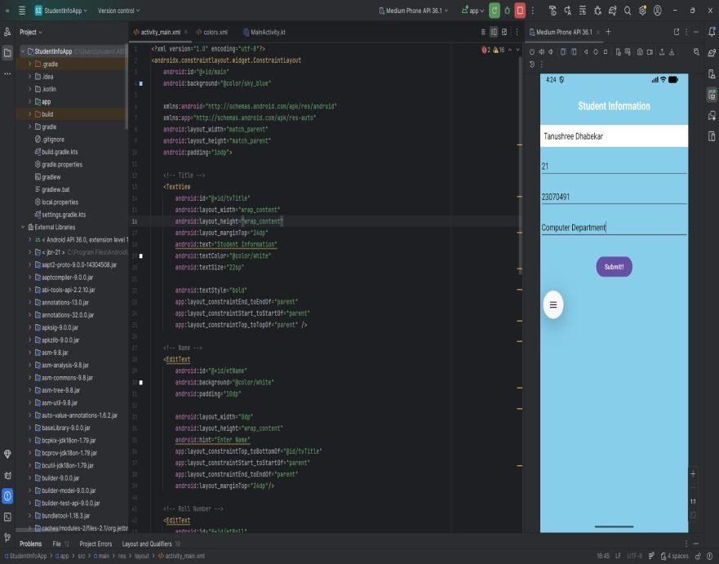
Output Analysis |  | The application successfully displays a Student Information Form
 |  | designed using XML in Android Studio. The interface uses
 |  | ConstraintLayout, which ensures proper alignment and responsiveness
Link of student |  | https://github.com/23071016/MWIOT-.git
Github profile where
lab assignment has
been uploaded
Conclusion |  | In this practical, an Android user interface was successfully designed  using XML layouts in Android Studio. Different UI components such as
 |  | TextView, EditText, and Button were used to create a Student
 |  | Information Form. The layout was built using ConstraintLayout, which
 |  | helps in creating responsive and well-aligned interfaces for different
 |  | screen sizes. Proper spacing and constraints were applied to maintain a
 |  | clean design. This experiment helped in understanding how XML is used
 |  | to design Android UI and how widgets are arranged within layouts to
 |  | create simple and user-friendly mobile applications.

Plag Report  (Similarity index < 12%) | 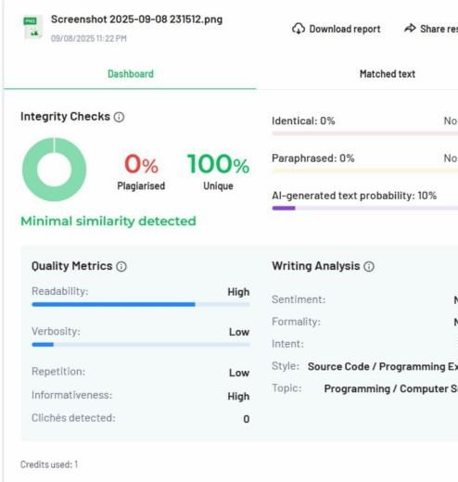
Date | 6-02-2026

